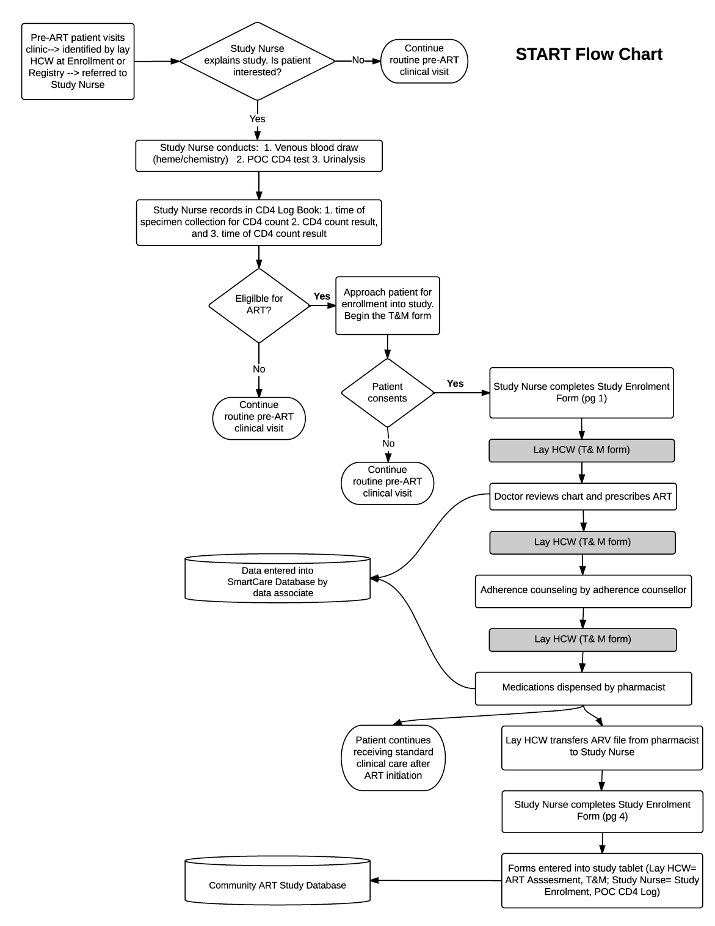
START MODEL FLOWCHART

Clinic Name: _______________________________________________________

ART ID | Patient First Name | Patient Surname | Date  (DD/MM/YY) | Time  specimen collection  for POC CD4 started  (HH:MM) | POC CD4 test result | Time  POC CD4 test result recorded  (HH:MM)

START Enrollment Form

Part 1: General
1. | Which model is patient being enrolled into?  CAG  UAG  Fast-Track  START
2. | Date of enrollment (DD/MM/YY): __ __/__ __/__ __
3. | Enrolled by:
4. | Clinic Name:
5. | Patient First Name:
6. | Patient Surname:
7. | ART ID:
8. | Sex (M/F):
9. | Date of Birth (DD/MM/YY): __ __/__ __/__ __
10. | Patient Mobile Number 1:
11. | Patient Mobile Number 2:

START Model
 | Please complete this section on the day of enrollment AFTER patient has left the clinic for the day. Use the clinic chart to complete these questions.
1. | Date of HIV Diagnosis (DD/MM/YY): __ __/__ __/__ __
2. | Was patient already enrolled in pre-ART before today?  Yes Go to question 2a  No Skip to question 3
 | 2a. If the answer to question 2 is yes, please indicate the date and value of the last CD4 count:
 | Date of last CD4 count (DD/MM/YY): __ __/__ __/__ __
 | Last CD4 Count: _____________
3. | Current WHO STAGE (as listed on today’s clinical visit form):  I  II  III  IV
4. | Does the patient currently have an acute opportunistic infection (based on review of today’s clinical visit form or discussion with the ART provider)?  Yes  No
5. | Was ART dispensed today?  Yes  No

11.0 Time & Motion Form
START Time & Motion Form

Please enter information here when you perform tasks during the workday. Do not complete from memory at the end of the day.

Clinic Name: __________________________________
Patient First Name: _____________________________
Patient Surname: _______________________________
ART ID: ________________________________________

 | DATE  (DD/MM/YY) | TIME  (HH:MM)
Clinician visit started
(Completed by Lay HCW)
Clinician visit ended
(Completed by Lay HCW)
Adherence Counseling started
(Completed by Lay HCW)
Adherence Counseling ended
(Completed by Lay HCW)
ART dispensed
(Completed by Lay HCW)

12.0 ART Assessment Form
Clinic Name: _______________________________________  ART ID: ___________________________________________  Patient First Name: __________________________________  Patient Surname: ___________________________________ | Date (DD/MM/YY):  |__|__|/|__|__|/|__|__|

For all sections assess whether patient understands following points after interacting with counselor
Section A. Enrollment and Assessment
- What is HIV? |  |  |  |  | □ Yes □ No
- What is AIDS? |  |  |  |  | □ Yes □ No
- How is HIV spread? |  |  |  |  | □ Yes □ No
- How can HIV be prevented? |  |  |  |  | □ Yes □ No
- Why is it important to disclose HIV status? |  |  |  |  | □ Yes □ No
- What are CD4 cells? |  |  |  |  | □ Yes □ No
- What is viral load? |  |  |  |  | □ Yes □ No
- What are the benefits of starting ART? |  |  |  |  | □ Yes □ No
Section B: cART Eligibility
- What is ARV? □ Yes □ No
- Who should start ART? □ Yes □ No
- What other considerations are there to understand before starting ART? □ Yes □ No
- Is starting ART an emergency? □ Yes □ No
- What are the benefits of starting ART? □ Yes □ No
- What is resistance? □ Yes □ No
- How does resistance occur? □ Yes □ No
- How can resistance be prevented? □ Yes □ No
- Why is it important to have perfect adherence? □ Yes □ No

Section C. cART Initiation
- Patient understands steps to developing a successful treatment plan? □ Yes □ No
- Patient understands the importance of knowing their ART medication regimen? □ Yes □ No
- Patient understands possible drug side effects? □ Yes □ No
- Patient understands that taking ART is life-long and they should not stop without consulting a doctor? □ Yes □ No
- Patient understands how resistance can be prevented □ Yes □ No

Section D. Patient Willingness
1. Is the patient willing to start ART at the present time?
□ Yes | If yes, what reasons does the patient give for being willing to start ART? (mark all that apply) | Knowledge:  - I feel unwell and ART will make me healthy again  - I feel well and ART will keep me healthy  - It is important to start ART quickly when you are sick to get healthy again  Prioritization:  - ART will help me continue to work  - ART will help me continue to take care of my family  - ART will minimize risks of giving HIV to my children through childbirth  - ART can help me avoid putting others at risk for HIV | Shared commitment/access:  - This clinic will take care of me and wants to help me  - Coming to clinic is well worth my time and effort  - I feel safer once I am on ART  - My spouse/partner is on therapy  Other, specify:
□ No | If no, what reasons does the patient give for being unwilling to initiate ART today? (mark all that apply) | Structural:  - Cannot return for follow-up because of transport costs  - Cannot return for follow-up because work responsibilities  - Cannot make a decision today because has to leave / left urgently for family/work  Health care delivery:  - Conflict with provider wants to seek care elsewhere  - Unhappy with clinic and wants to seek care elsewhere  Psychosocial:  - Prefers spiritual or traditional treatment to ART  - Too emotionally distressed to make decision or plan  - Is intoxicated and unable to make a plan  - Does not accept HIV diagnosis  - Feels fine and does not want treatment  - Does not want to take indefinite treatment |  | - Fears potential side effects  - Initiating treatment would lead to risk of disclosure and family or community rejection  - Initiating treatment would lead to risk of disclosure and conflict with spouse / domestic violence  - Initiating treatment would lead to risk of disclosure and loss of job or work  Other, please specify:
Comments:

13.0 START Assessment Form: Guide to Expected Respondent Answers
Section A: Enrollment Assessment
1. What is HIV?
  - HIV is a virus that attacks the body
  - It damages your ability to fight germs and disease
  - The virus makes many copies of itself every day if you are not on treatment
  - Without treatment people progress from no symptoms to minor illness to severe life-threatening illness and death

2. What is AIDS?
  - AIDS occurs when the body is overcome by the HIV virus and becomes weak due to other illnesses
  - HIV causes AIDS months to years after infection

3. How is HIV spread?
- Unprotected sex is the most common method
- Sharing needles or blood contaminated sharp objects (razors, knives, etc.)
- Mother to child either before, during or after delivery (in the womb, during delivery, or while breastfeeding)
- Infected body fluids in contact with
    - Soft moist skin in the mouth, nose, vagina or rectum
    - Cuts in the skin
- Traditional beliefs that facilitate HIV transmission (sexual cleansing, wet nursing, dry sex, pre-coital pubic shaving with shared razor, etc.)
- HIV is NOT spread through sharing food or utensils, touching, kissing, mosquitoes, or curses

4. How can HIV be prevented?
- Using condoms when engaging in sexual contact
- Abstaining from sex
- Knowledge of sexual partner’s HIV status
- Being faithful to your one partner/spouse
- Becoming circumcised if an HIV negative male (can reduce risk of transmission)
- Taking ARVs perfectly and using condoms when engaging in sexual contact

5. Why is it important to disclose HIV status?
- Sharing your test results with someone you trust who can support you is associated with better success in managing HIV
- Your family should become a source of support and help in your treatment of HIV
- Notifying your sexual partner so they can be tested also can help stop HIV spread

6. What are CD4 cells?
- The immune system works in your body to fight infections and keep you healthy
- CD4 cells are the “soldiers” of your immune system army
- CD4 cells recognize germs in your body, and they work with other cells to destroy them
- HIV attacks and destroys your CD4 cells
- When CD4 cells are destroyed by HIV, the immune system does not know how to fight germs

7. What is viral load?
- Viral load is the amount of HIV virus in the blood
- The lower the amount of HIV virus in the blood the better
- CD4 cells are the “soldiers” of your immune system army
- CD4 cells recognize germs in your body, and they work with other cells to destroy them
- HIV attacks and destroys your CD4 cells
- When CD4 cells are destroyed by HIV, the immune system does not know how to fight germs
- When the amount of HIV virus increases, eventually you don’t have enough CD4 cells to fight HIV and other germs that enter your body, and you progress to AIDS

8. What are the benefits of starting ART?
- Starting HIV treatment before you become sick and have AIDS will make it easier to lower the HIV virus in your blood and increase your CD4 cells faster
- It will also make the potential side effects from treatment easier to tolerate
- It will prevent you from developing more serious infections, and improve your chance of living a normal life with HIV

Section B: ART Eligibility
1. What is ARV?
- ARV stands for Anti-Retro Viral
- ARVs are medicines that help control the HIV virus in the blood
- ART is Anti-Retroviral Therapy, and refers to the combination of ARVs which are used to fight HIV

2. Who should start ART?
- You cannot always tell by looking at someone if they need ART
- Even if you look and feel healthy, your immune system may already be weakened (low CD4 cell count), and you may benefit from starting ART to prevent you from getting sick
- You should start ART if you are experiencing illnesses or your immune system is weakened (low CD4 cell count)
- An HIV+ person does not always need to start ART immediately, and some people may have no illnesses and a healthy immune system (high CD4 cell count) and can delay ART, but should remain in care with regular follow up

3. What other considerations are there to understand before starting ART?
- Several considerations are associated with success when starting ART
  - Disclosing your status to someone that you trust is associated with better success on ART
  - Identifying a treatment supporter or buddy that can help you with ART is very important
  - Identifying linkages to the community through home based care, treatment support groups, and other community services will help you be more successful with your treatment
  - Discussing fears and questions with your health care team members
  - Always keeping a supply of medication with you and so that you never run out
  - Heavy drinking of alcohol and depression can lower your adherence and reduce your success when taking ART

4. Is starting ART an emergency?
- Starting ART is an individual decision and one is not forced
- Those who are already sick with AIDS will need ART, however starting ART is never an emergency
- Opportunistic Infections and other illnesses should be identified and treatment started before starting ART
- ARVs may cause side effects, however most people tolerate ART well, and specific potential side effects will be discussed prior to starting ART

5. What are the benefits of starting ART?
- ART increases the CD4 cell count
- ART allows the body to better fight infections by restoring the immune system
- A healthy immune system will lead to fewer hospitalizations
- ART can allow you to live longer so that you can care for your children and family
- ART can help you gain weight, feel more energetic, and improve your sexuality (sexual health?)
- ART can decrease the risk of transmitting HIV to others

6. How does resistance occur?
- Resistance can occur when you miss doses of your medicine or take them incorrectly. The HIV virus uses this chance to make more and more different copies of itself that are so different that your medicines stop working
- Resistance can also occur if you get infected with an HIV virus that is already resistant to the medications that you are taking, or if you get re-infected with a resistant HIV virus to the medications that you are taking (always practice safe sex to avoid infection or re-infection)

7. How can resistance be prevented?
- You can prevent resistance through perfect adherence
- Perfect adherence requires a patient to take their medicines every day at the right time and in the right way (dose and combination)
- It also means always collecting your medicines on time so that you never run out of ART, and making sure that you take them when travelling away from home (funerals, holidays, other emergencies) or while away at work (miners, truck drivers, etc.)

8. Why is it important to have perfect adherence?
- The best way to live a long life with HIV is to keep the first ART combination working as long as possible
- When ART is not taken properly, the virus can change (viral mutation) and then the medicines stop working and resistance has developed
- Once resistance occurs, it is NOT reversible and will last forever
- When resistance develops you are no longer able to fight the HIV in your body and you risk getting sick and dying
- It will then become necessary to find a different combination of ART medicines to treat your HIV virus. The second ART combination may not work as well as the first ART combination and it may have more side effects, and can also be very expensive
- Without perfect adherence, eventually you run the risk of having no treatment options for HIV

Section C. ART Initiation
1. Patient understands steps to developing a successful treatment plan?
- Keep all scheduled appointments and pharmacy refills
- Make sure the health facility knows how to contact you and your buddy (up to date phone numbers and address) and contact your health care facility or provider for any problems with medications (side effects, lost medicine, unable to make appointment, etc.) or new illnesses
- Use a defined schedule for taking your ARVs and use helps such as calendars, pill boxes, or checklist to ensure that doses are not missed
- Involve family members or a treatment supporter (buddy) in your care and keep them up to date with your progress
- Stay active with good nutrition and exercise
- Plan for emergencies before they happen (rainy season, floods, funerals, holidays, lost medicine) so that you do not run out of medication
- Do not STOP your medicines without discussing with a health care provider
- Do not take other herbal or over the counter medicines without discussing with your health care provider

2. Patient understands the importance of knowing their ART medication regimen?
- Know the names of the medicines and how they are to be taken
- Know the potential side effects and what to do if they occur
- Know about potential drug interactions between your medicines

3. Patient understands possible drug side effects?
- Common side effects include: diarrhea, abdominal pain, nausea, vomiting, rash
- Patient understands possible side effects and to return to the doctor if they persist

4. Patient understands that taking ART is life-long and they should not stop without consulting a doctor?
- Patient realizes that ART is life-long and that taking medication daily as prescribed by their doctor is the way to live a healthy and productive life with HIV
- The patient understands that the medication will make them feel better, but this is not a reason to stop taking their medication at any point

Dried Blood Spot (DBS) Viral Load Log Book
Dried Blood Spot (DBS) Viral Load Log Book

Clinic Name: _______________________________________________________

Date of Specimen Collection  (DD/MM/YY) | Time of Specimen Collection  (HH:MM) | ART ID | Patient First Name | Patient Surname

